Task 3
Zoo brochure

You may use a mixture of electronic and manual methods in responding to this task. Your master page must be created using software.

In this assessment task you should use your knowledge and skills in 2D graphic communication to show that you can produce work which meets the required standards for this Unit.

Things to remember before you start:

- You should have already developed the skills and knowledge in class to enable you to do this task — if you are unsure then you must let your assessor know.
- You cannot copy other work or ask any other class member for help.
- If you need advice, then you must ask your assessor. As this is an assessment, they might not be able to answer your question directly.

Information

A new ethical wildlife park is being created by the company 'Wild Times'.

They are hoping to set up a wildlife park that will encourage children to become interested in animals, conservation and ecology. Their new park will include animal exhibits, a fun park and various information stands, kiosks, food stalls and a gift shop.

'Wild Times' employed a graphic designer to create a corporate logo and select a typeface that will appeal to the target market. These will be supplied to you as part of the task.

You must:

- produce a leaflet to inform young people about animals, ecology and/or conservation, whilst also promoting the facilities of the park
- ensure your tri-fold leaflet contains at least one cut-away or window
- produce at least two preliminary layout designs for a tri-fold leaflet. The leaflet must include the corporate logo on at least one panel
- evaluate the preliminary layouts and make a clear decision which will be developed into a DTP document
- produce a fully completed DTP tri-fold leaflet. The leaflet must include the corporate logo on at least one panel and be guided by the preliminary layout

In tackling your work you should:

- consider information likely to be found in a tri-fold leaflet for a wildlife park and how best to communicate with a younger target market

- plan where the cut-away or window will be placed

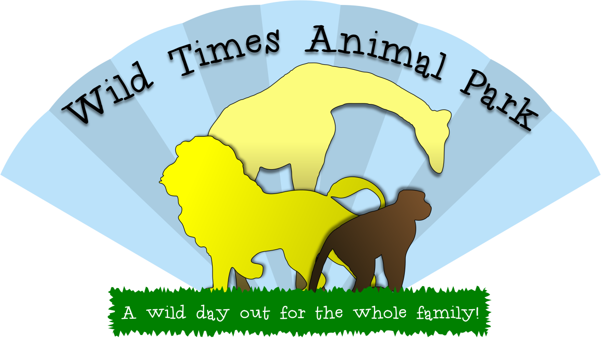

As part of this assessment task you will be provided with the corporate logo.

The file is provided in Portable Network Graphic (PNG) format at 350dpi. It has a transparent background.

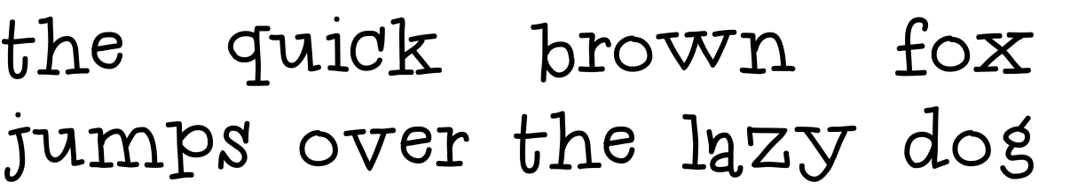

The corporate typeface is 'Idolwild'. The font file is supplied in TrueType format.
This typeface is provided to assist in creating a layout that unifies with the logo.
You do not need to use this typeface to complete this task.
The cut-away or window must reveal part of another panel in the leaflet.

Your leaflet must contain at least one cut-away.

A simple cut-away is shown left.
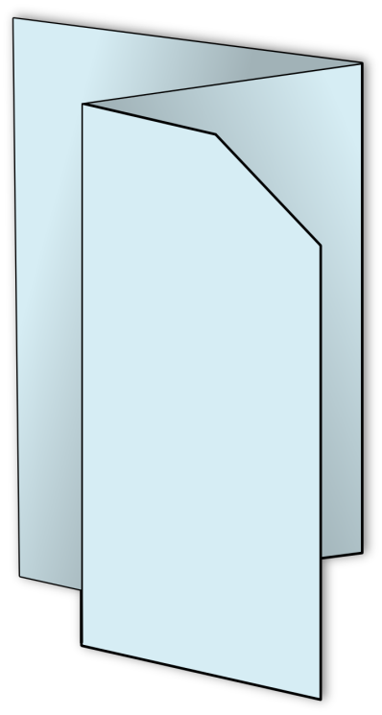

The cut-away or window must reveal part of another panel in the leaflet.

Your leaflet must contain at least one cut-away.

A simple cut-away is shown left.
The cut-away or window must reveal part of another panel in the leaflet.

Your leaflet must contain at least one cut-away.

A simple cut-away is shown left.

